**Splash screen xml**

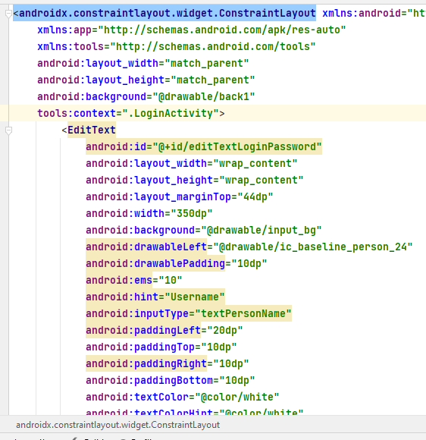

**Splash screen Java**

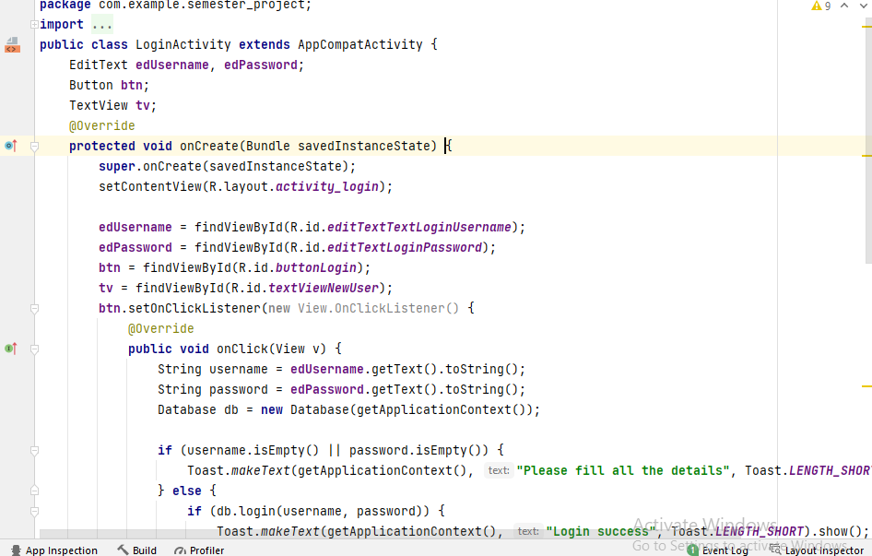

**Splash screen output**

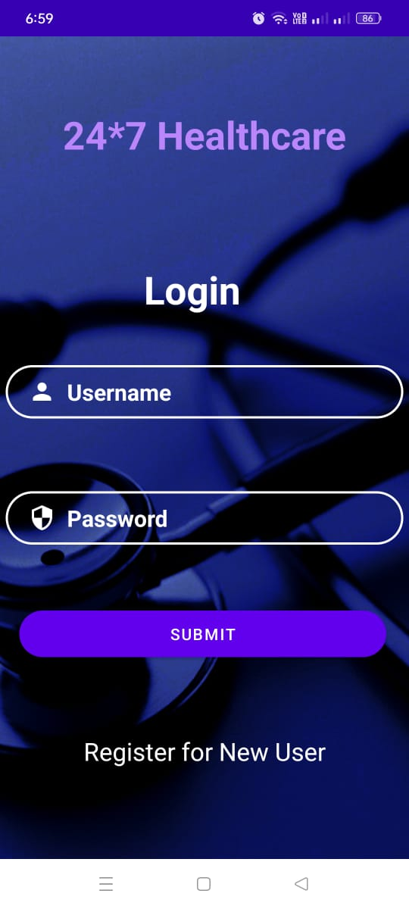

**Reposittority link**

[**https://github.com/saadahmad88/Andriod_Assignment**](https://github.com/saadahmad88/Andriod_Assignment)